Computer Language Coding Concepts

Parameters in a Command Reference in a Diagram
Parameters in a command reference have been conceptually explained in the article Parameters in a Command Reference.

This article only illustrates how parameters in a command reference look in a diagram.

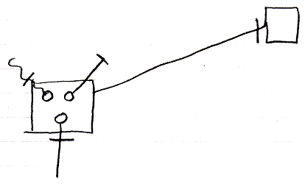

The larger square on the left is a command reference. It is tied to its reference target, the square on the right, with an object line, which is a solid line. The circles inside the square on the left are the parameters of the command reference. The lines tied to those are the parameter passing types. The parameter passings are the lines connected to the circles, that are marked with an access mark. The square on the right could have had the same contents as the square on the left, because both command reference and command definition represent the same command definition.

See also: Parameters in a Command Reference,
Creation Behavior of Command Calls in a Diagram

Author & Copyright: Jan-Joost van Zon Date: August 9, 2008 – August 9, 2008 Location: Oosterhout, The Netherlands Status: Finished

